sEQUENCE GENERATOR

A sequence generator is a digital circuit that produces a predefined sequence of binary or numerical outputs. Sequence generators are commonly used in testing, encryption, communication systems, and state machines.

DESIGNING STEPS

* Find number of flip flops using L ≤ (2n − 1) where L is length of sequence, n indicate number of flip flop needed.
* Write truth table for this sequence using n flip-flops.
* Third step is the K-map optimization problem.

**Gray Code Sequence**

Produces a sequence where only one bit changes between consecutive states.

module gray_code_generator (

input clk,

input reset,

output reg [2:0] gray

);

reg [2:0] binary;

always @(posedge clk or posedge reset) begin

if (reset)

binary <= 0;

else

binary <= binary + 1; // Increment in binary

end

always @(*) begin

gray = binary ^ (binary >> 1); // Binary to Gray conversion

end

endmodule

**Binary Sequence Generator**

**(1-0-1-1-0)**

L ≤ (2n) here, L=5 hence , n=4

module sequence_generator_10110 (

input clk, // Clock signal

input reset, // Reset signal

output reg seq_out // Sequence output

);

// State encoding

reg [2:0] state; // 3-bit state register to represent 5 states

// State Definitions

parameter S0 = 3'b000, // State for '1'

S1 = 3'b001, // State for '0'

S2 = 3'b010, // State for '1'

S3 = 3'b011, // State for '1'

S4 = 3'b100; // State for '0'

// Sequential Logic for State Transition

always @(posedge clk or posedge reset) begin

if (reset)

state <= S0; // Reset to the initial state

else begin

case (state)

S0: state <= S1; // 1 -> 0

S1: state <= S2; // 0 -> 1

S2: state <= S3; // 1 -> 1

S3: state <= S4; // 1 -> 0

S4: state <= S0;

default: state <= S0; // Default to initial state

endcase

end

end

// Output Logic

always @(*) begin

case (state)

S0: seq_out = 1;

S1: seq_out = 0;

S2: seq_out = 1;

S3: seq_out = 1;

S4: seq_out = 0;

default: seq_out = 0;

endcase

end

endmodule

**Fibonacci Sequence Generator**

Generates a Fibonacci sequence

Fn=Fn−1+Fn−2

module fibonacci_generator (

input clk,

input rst,

output reg [3:0] fib

);

reg [3:0] prev1, prev2;

always @(posedge clk or posedge rst)

begin

if (reset) begin

prev1 <= 1; // Initialize first two no

prev2 <= 0;

fib <= 0;

end else begin

fib <= prev1 + prev2; // Fibonacci

prev2 <= prev1;

prev1 <= fib;

end

end

endmodule

1. **Reset Behavior:** Ensure the generator starts with a known state.
2. **Timing and Clock:** Ensure timing constraints are met, especially in high-frequency applications.
3. **State Encoding:** Optimize the state representation for efficient hardware usage.
4. **Modularity:** Use parameters or constants to modify the sequence dynamically.

**Pseudo-Random seq**

Uses Linear Feedback Shift Registers (LFSRs) to produce pseudo-random sequences.

module lfsr_sequence (

input clk,

input rst,

output reg [3:0] lfsr

);

always @(posedge clk or posedge rst) begin

if (reset)

lfsr <= 4'b1001;

// Initialize LFSR with non-zero value

else

lfsr <= {lfsr[2:0], lfsr[3] ^ lfsr[2]};

// Feedback for randomness

end

endmodule

**COUNTER**

Synchronous Counter: synchronous counter has one global clock which drives each flip flop so output

changes in parallel.  Tdelay= tpd

Johson counter

Also called twisted ring counter/switched tail / Mobile walking

Form by connecting complement of output of last stage back to input of shift register.

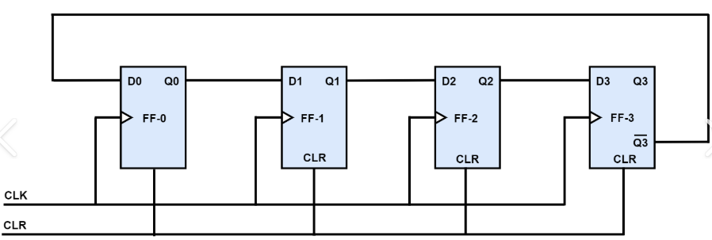

CLOCK FREQUENCY - F/2N

Drawback:

* High number of unused states.
* Enter to lock up state.

module johnson_counter(

input wire clk, // Clock input

input wire reset, // Active high reset

output reg [3:0] q // 4-bit Johnson counter output

);

always @(posedge clk or posedge reset)

begin

if (reset)

begin

q <= 4'b0000; // Initialize the counter

end

else

begin

q <= {q[2:0], ~q[3]}; // Shift left and invert the MSB

end

end

endmodule

Ring Counter

Formed by connecting the output of last stage back to input of the shift register.

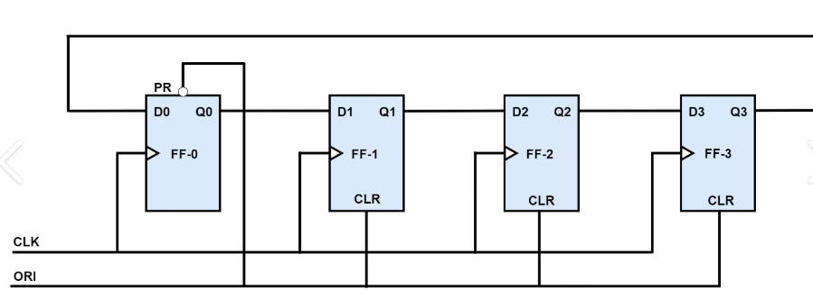

CLOCK FREQUENCY - F/2N

Drawback:

* Need to start the counter or need extra gate to make itself start.
* Can generate on N state

module ring_counter

(

input wire clk, // Clock input

input wire reset, // Active high reset

output reg [3:0] q // 4-bit ring counter output

);

always @(posedge clk or posedge reset)

begin

if (reset) begin

q <= 4'b0001; // Initialize the ring counter

end

else begin

q <= {q[2:0], q[3]}; // Rotate left

end

end

endmodule

N bit- MOD N

Used state – 2N

Unused state – 2N -2N

N bit- MOD N

Used state – N

Unused state– 2N -1

DECODER COUNTER

module decade_counter(

input wire clk, // Clock input

input wire reset, // Active high reset

output reg [3:0] count // 4-bit counter output);

always @(posedge clk or posedge reset) begin

if (reset) begin

count <= 4'b0000; // Reset counter to 0000

end else if (count == 4'b1001) begin

count <= 4'b0000; // Reset to 0000 WHEN 9

end else begin

count <= count + 1; // Increment counter by 1

end

end

endmodule

**BCD COUNTER**

module bcd_counter(

input wire clk, // Clock input

input wire reset, // Active high reset

output reg [3:0] bcd // 4-bit BCD output );

always @(posedge clk or posedge reset) begin

if (reset) begin

bcd <= 4'b0000; // Reset BCD counter to 0000

end else if (bcd == 4'b1001) begin

bcd <= 4'b0000; // Reset to 0000 when it reaches 9

end else begin

bcd <= bcd + 1;

end

end

endmodule

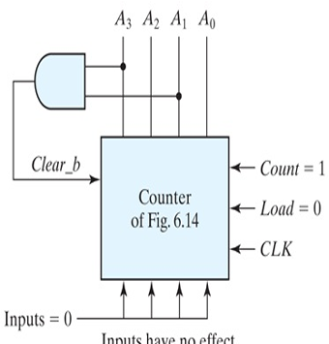

Asynchronous Counter: counter is a cascaded arrangement of flip-flops where the output of one flip-flop drives the clock input of the following flip-flop.  Tdelay= tpd

Ripple counter

|  |  |  |
| --- | --- | --- |
| Clk | edge | nature |
| Q |  | DOWN |
| Q |  | UP |
| Q’ |  | UP |
| Q’ |  | DOWN |

* All flip flop works in Toggle mode.
* Full state = 2n, Full state = UP +DOWN
* For DOWN counter use PRESET and for UP counter use CLEAR
* ACTIVE HIGH- AND / OR & ACTIVE LOW- NAND /NOR
* DUTY TIME = (ON TIME) / (ON TIME + OFF TIME)

UP/DOWN COUNTER

module up_down_counter(

input wire clk, // Clock input

input wire rst, // Active high

input wire up_down, // Control

output reg [3:0] count

);

always @(posedge clk or posedge rst) begin

if (reset) begin

count <= 4'b0000; // Resst 0000

end else

if (up_down) begin

count <= count + 1; // Increment (up)

end else begin

count <= count - 1; //Decrement(down)

end

end

endmodule

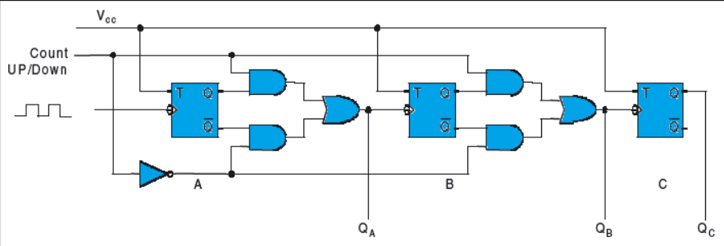

UP COUNTER

module up_counter(

input wire clk, // Clock input

input wire reset, // Active high reset

output reg [2:0] count // 3-bit counter output

);

// Always block to handle counting on positive clock edge or reset

always @(posedge clk or posedge reset) begin

if (reset)

begin

count <= 3'b000; // Reset counter 000

end

else begin

count <= count + 1; // Increment by 1

end

end

endmodule

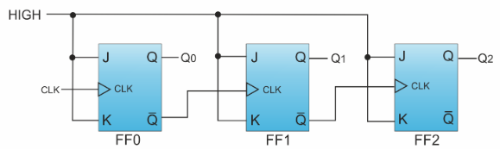

DOWN COUNTER

module down_counter(

input wire clk, // Clock input

input wire reset, // Active high reset

output reg [3:0] count // 4-bit counter output

);

// Always block to handle counting on positive clock edge or reset

always @(posedge clk or posedge reset)

begin

if (reset) begin

count <= 4'b1111; // Reset to 1111

end else begin

count <= count - 1; // Decrement by 1

end

end

endmodule

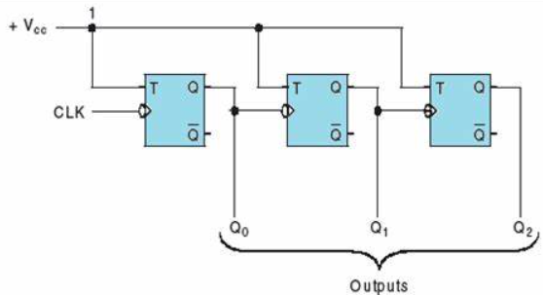

|  |  |
| --- | --- |
| SYNCHRONOUS COUNTER | ASYNCRONOUS COUNTER |
| All flip flop are clocked at a time . | Only the first flip-flop is driven by the clock. The other flip-flops are triggered by the output of the preceding flip-flop. |
| Faster, since all flip-flops change state simultaneously on the clock edge. | Slower, due to the propagation delay between flip-flops. |
| More complex due to the requirement for synchronizing all flip-flops. | Simpler in design as only the first flip-flop is clocked. |
| Consumes more power, as all flip-flops are clocked simultaneously. | Generally, consumes less power as only one flip-flop receives the clock signal. |
| Errors are easier to control or detect due to synchronized state changes. | Difficult to control or detect errors due to the asynchronous nature. |
| Suitable for high-speed, reliable counting applications like in CPUs or complex digital systems. | Suitable for simple, low-frequency counters or applications where speed is not critical. |